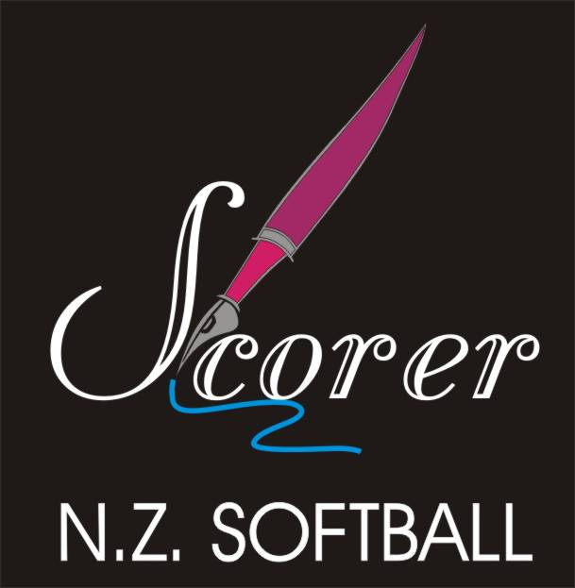
Softball New Zealand Scorers Association Inc

CHIEF SCORER

Lil Natana

33 Ward Street

Kawerau

Bay of Plenty 3127

Tel: 07 323 6357 (H)

Mobile: 027 257 8762

Email: snzsachief@gmail.com

NORTHERN DEPUTY

Lynnette Leathart

1 Myna Place

Weymouth

Auckland 2103

Tel: 09 2674061 (H)

Mobile: 027 209 7293

Email: snzsanorthern@gmail.com

CENTRAL DEPUTY

Ian Ditfort

2 Ashwood Drive

Witherlea

Blenheim 7201

Tel: 03 577 8299 (H)

Mobile: 021 0266 4752

Email: snzsacentral@gmail.com.

SOUTHERN DEPUTY

Marie Byrne

97a Olliviers Road

Phillipstown

Christchurch 8011

Tel: 03 381 8628 (H)

Tel: (03) 941 6502 (W)

Mobile: 027 471 6539

Email: snzsasouthern@gmail.com

NZ STATISTICIAN

Elaine Karsten

6 Skye Street

Invercargill 9812

Tel: 03 216 5591

Mobile: 027 210 3057

Email: snzsastats@gmail.com

Panel Meeting held on 8/9 August 2015.

- Draft Tournament Appointments done.
A very good response with the only tournament requiring one
(1) more scorer is the U15 B&G SI in Alexandra.

- The new Scoring Manual and the Stat trak Manual
have taken longer than we anticipated, but are in hand and we
have two people working on these.
- Co Ordinators,
We are looking for scorers interested in the following:
- Funding
- Website
- Uniforms
- Tournaments
- Equipment
- Exams
- Data Base
Please contact our Chief Scorer, Lil Natana if you are interested in
helping with these.

- Score Sheet
Last season at some tournaments, scorers were told to use the
B (Balls) and S (Strikes) columns for SB and CS. This was not
correct, as there is already a check for SB’s and CS’s.
These S and B columns are for just as stated, balls and strikes.
Some coaches ask for these checks, so that is what they are
there for.

- Scorer’s Levy
Accounts for these will be sent out in October, with Active
Scorer’s levy being $25.00 and Local Scorers only
(i.e Not attending any tournaments) $15.00.

- Uniforms
The Blue uniforms are now gone and cannot be worn at any
Tournament. The NPC Tournament Scorers must have the full
new black uniform. For the other tournaments, those who
don’t have the new uniform, dress black trousers, (no jeans)
plain shorts, ¾ pants or a plain black skirt (not a full length
skirt) with no markings on any, the official scorers polo shirt or if that is
not possible a black or white polo shirt and a black jacket. New scorers
may wear a black or white polo shirt with the rest of the uniform as
above. We are in the process of negotiating a cheaper version of our
black uniform.

Panel Meeting held on 8/9 August 2015.

- Analysis
It has been observed that some badged scorers are taking too long to analyse their scoresheets at tournaments, from anything up to and over two hours. This puts a burden on the statisticians, as they have to put the information into the computer, and sometimes they get later game time scoresheets in before some earlier ones are finished. This also means a regular balance cannot be done until all the scoresheets are in. The statistician expects to take the last game time scoresheets back to their accommodation, but not extra ones from an earlier time.

- Grading
The grading has been updated and is available on the website. There have been some upgrades.

- Statisticians
Far too much paperwork is being printed and sent to the SNZ Statistician. Everything is now sent out electronically to teams, coaches and Associations, so there is no need for all the results sheets, batting pitching and fielding. We only need copies of the Top Batter etc. Daily Reports, the Final Balancing Sheet filled out correctly, the Sheet with the Top Batter, Top Pitcher, Top Catcher and MVP. All these could be included on the flash drive.
Also, please include Day 4 Top Batters and Top Pitchers, or for longer tournaments the last day of play, sending this to SNZ for the Website. These last day statistics should be sent to SNZ on the day after the tournament finishes.

- Communication
Please let us know if there is something you feel should have been done and hasn’t been. We are your representatives on the Panel and we want everyone to be happy in their work.

Yours in Softball
Lil Natana (Chief Scorer) Lynnette Leathart (Northern Deputy) Ian Ditfort (Central Deputy)
Marie Byrne (Southern Deputy, Elaine Karsten (SNZ Statistician)

